Weekly Construction Progress Report – Week 27
Harrow Bay Offshore Wind · 29 Jun – 05 Jul 2026
Elena Márquez · 06 July 2026 · HB-PM-RPT-2026-W27

1. Summary
No piling this week (seasonal piling restriction). The total remains 10 of 40 monopiles. The foundation campaign is 2 piles behind the Rev 2 baseline (12 planned). Waiting on weather amounted to 10 hours.
Area | Status | Comment
Overall schedule | Amber | 10/40 monopiles vs. 12 planned
Foundations | Amber | TPs installed: 10
Offshore substation | Green | Jacket installed 27 Jun
Cables | Green | Manufacturing on schedule
HSE | Green | No incidents

2. Progress
Metric | This week | Cumulative | Plan (cum.) | Variance
Monopiles installed | 0 | 10 | 12 | -2
Transition pieces installed | 2 | 10 | – | –
Waiting on weather (h) | 10 | 213 | – | –
Persons on board (avg.) | 102 | – | – | –
Man-hours MV Sea Atlas | 8,654 | 106,952 | – | –
Lost time injuries | 0 | 0 | 0 | 0
Recordable injuries | 0 | 0 | – | –
Near misses reported | 0 | 3 | – | –
HSE observation cards | 17 | – | – | –

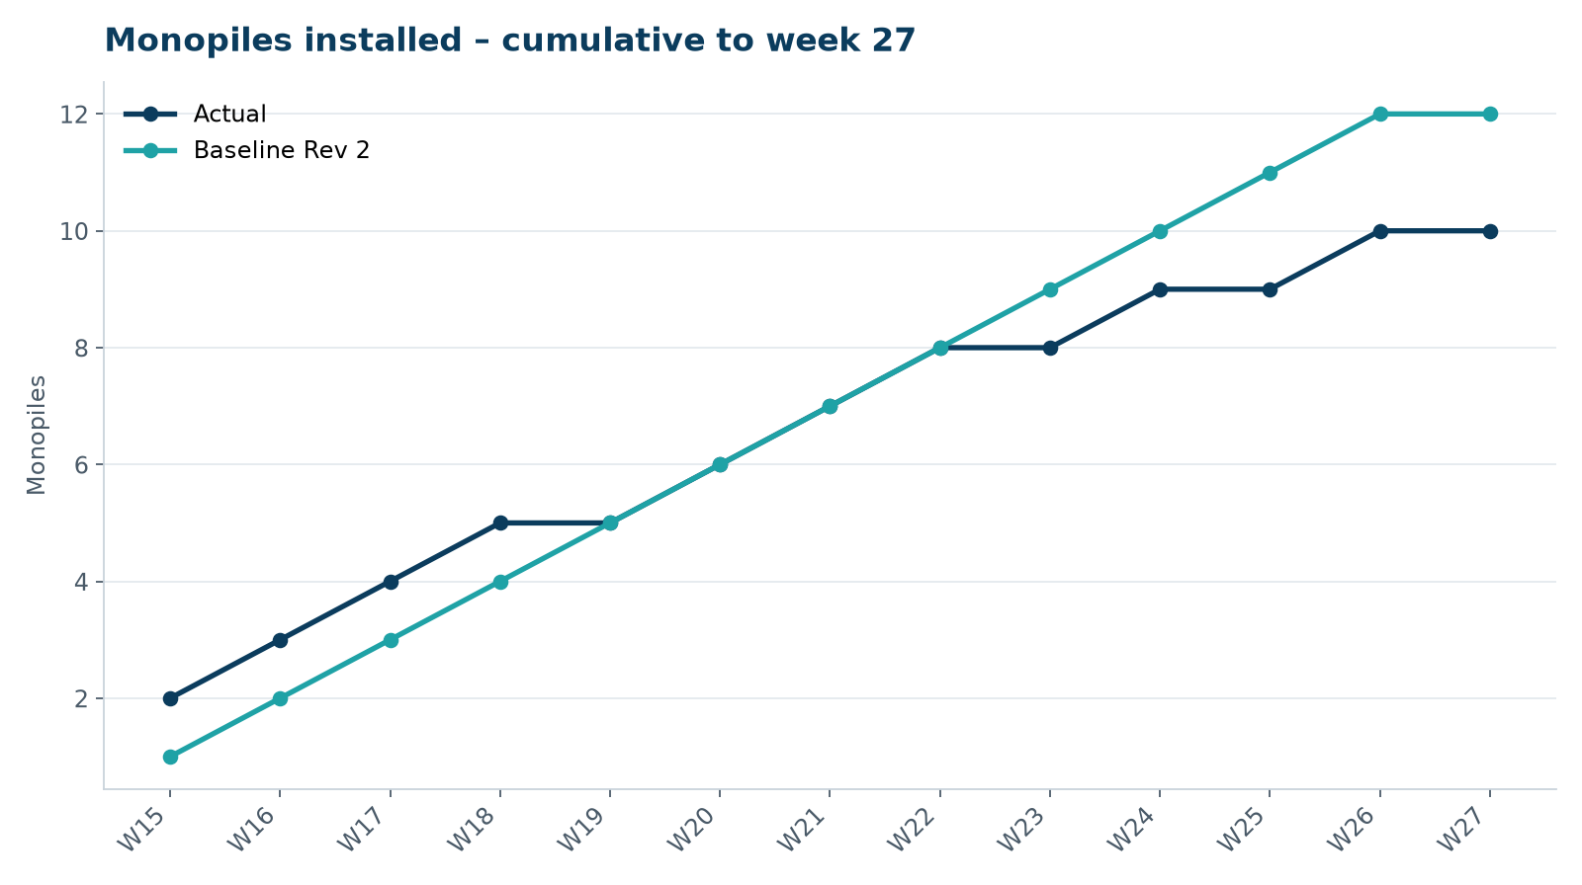
Figure 1 – Monopile installation progress, W15 to W27

3. Key activities this week
- Seasonal piling restriction in force from 1 July to 31 July (consent condition 14).
- Transition pieces HB-A09 (30 June) and HB-A10 (2 July) installed; bolt tensioning campaign on HB-A01 to HB-A10 started.
- MV Sea Atlas returned to the Port of Eastholm on 4 July.

4. Health and safety
No lost time injuries. 17 observation cards submitted; top theme: hand protection.

5. Environment
- No piling this week; passive acoustic monitoring stations HB-PAM-01 to -04 operational.

6. Issues and risks
- HB-RISK-001 weather: 10 h downtime this week.

7. Look-ahead next week
Port maintenance period for MV Sea Atlas; export cable route survey.
Prepared by Project Controls (Gareth Lewis); approved by Elena Márquez. Distribution: project team, Steering Committee, Halden Turbine Systems, Lenders' Technical Adviser.

